**Task 3(List Tuples Dictionaries)**

**Date : 9nd September 2020**

**Deadline : Next meeting(11th September)**

Submission Link: https://forms.gle/BRox4UDN3edT6xtq5

1) Print the following pattern taking the number of rows as input from the user

Input : 4

*

* *

  * * *

* * * *

2)Print the following pattern taking the number of rows as input from the user(mirror image of Z)

Input: 5

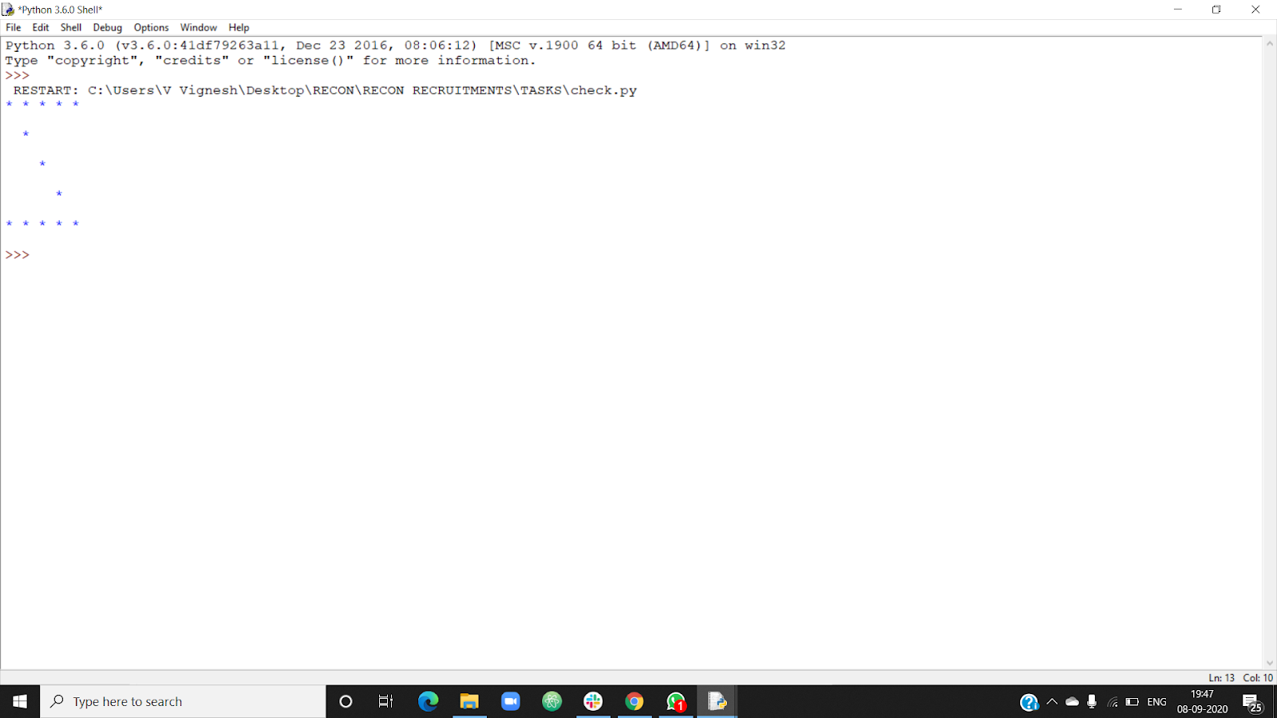

3) Given a two Python list. Iterate both lists simultaneously such that list1 should display item in original order and list2 in reverse order

4) Write a program to remove empty strings from the list of strings.

5)Write a program to reverse a tuple

6) Write a program to copy element 44 and 55 from the following tuple into a new tuple

tuple1 = (98, 67, 33, 44, 55, 78)

7) WAP and create a dictionary to hold information about pets. Each key is an what kind of animal it is, and each value is the pet’s name

 8) WAP to find the highest 3 values in a dictionary.